Public Schools Foundation of Santa Cruz County
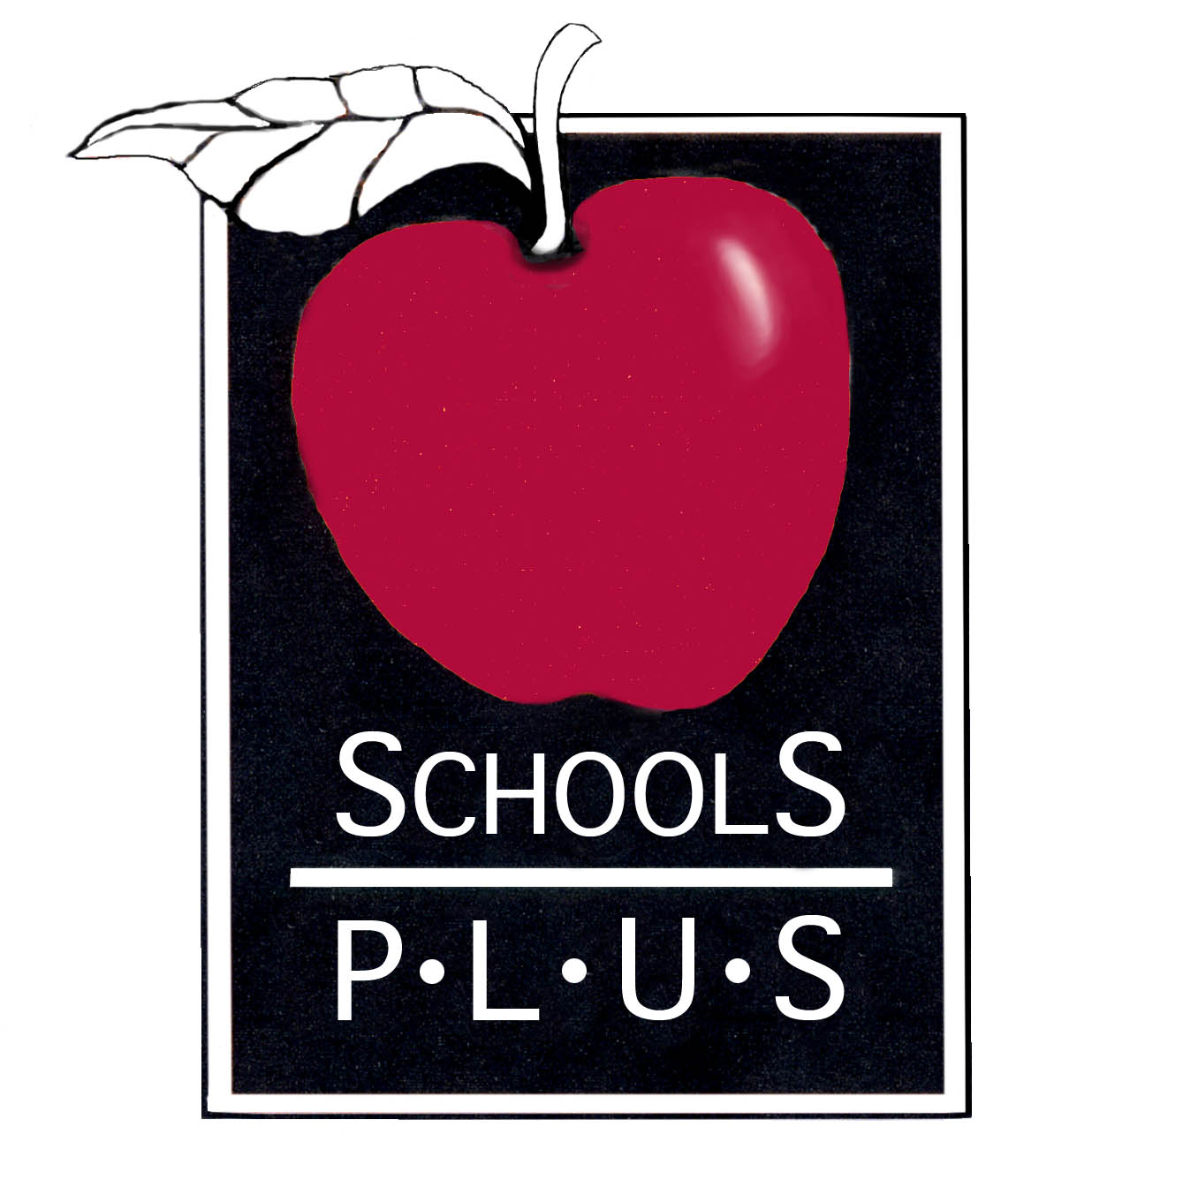

Schools Plus September Social

Showcasing our 2017-18 School Year Grant recipients

Saturday, September 29th, 2018

Appetizers at 3:00
Program begins at 4:00

at the Community Foundation of Santa Cruz County
on the Terrace
7807 Soquel Drive in Aptos

please rsvp by Friday, September 21st
nbricmont@yahoo.com / 831.419-8754

Schools Plus Foundation is a non-profit community organization whose
purpose is to secure and distribute contributions from foundations,
corporations, community and individuals for the educational benefit
of students enrolled in Santa Cruz County public schools.
www.schoolsplus.us

